**Notes in ‘Quantifying the seasonal variations in grapevine yield components based on pre- and post-flowering weather conditions ’**

**Notes in Document**

**'05b-tomazic':**

Highlight variability wine yeld

Highlight methereology impacts

Highlight climate approach

Highlight features

Highlight grape wine yeld formation

Highlight motivation predict wine

Highlight references

Highlight : However, quantitative relationships between various yield components and climatic factors at field scales are still lacking. By *\cite{zhu2020quantifying}*

Highlight : Seasonal differences in weather conditions cause marked variation in grapevine yield.  *\cite{zhu2020quantifying}*

Highlight : we quantified the correlation between weather conditions during the key development stages and the yield components of Vitis vinifera L. Sauvignon blanc growing under cool-climate conditions *\cite{zhu2020quantifying}*

Highlight : A multivariable mixed linear model was used to assess the relationship between various yield components and weather conditions *\cite{zhu2020quantifying}*

Highlight : of temperature for all yield components occurred mainly before 50 % flowering either in the previous season (during inflorescence initiation) and the current season, indicating the importance of the pre-flowering period on yield formation. *\cite{zhu2020quantifying}*

Highlight : Out of all weather factors, maximum daily temperature had the largest effect on bunch number and overall yield and strongly influenced berry number and bunch mass. Rainfall near flowering time had a negative effect on berry mass and bunch mass, but post-flowering rainfall had a strong positive effect. The statistical model explained 60 to 85 percent of the seasonal variations in bunch number, berry number, berry and bunch mass and yield per vine.  *\cite{zhu2020quantifying}*

Highlight : Yield per hectare is the product of vines per hectare, shoots per vine, inflorescences per shoot, berry number per bunch and berry mass *\cite{zhu2020quantifying}*

Highlight : Seasonal or inter-seasonal factors, especially temperature, radiation and water status, have pronounced effects on the fruitfulness and overall yield of grapevine (Buttrose, 1969b; Buttrose, 1974) *\cite{zhu2020quantifying}*

Highlight : Grapevines may generally form up to four inflorescences on a shoot (Watt, 2010) *\cite{zhu2020quantifying}*

Highlight : (anlagen, potential bunches for the following season *\cite{zhu2020quantifying}*

Highlight : Maintaining stable yields from year to year is essential for achieving a consistent fruit quality and supply, which are crucial within the context of increasing competition in the international market (Kliewer and Dokoozlian, 2005; Trought, 2000).  *\cite{zhu2020quantifying}*

Highlight : Whether or not anlagen become inflorescence or tendril primordia will depend on temperature and radiation conditions around the bud at the time differentiation takes place (Buttrose, 1969a, 1969b, 1970). High radiation intensities or temperatures during initiation will encourage inflorescence primordia development, while shaded or cool conditions will lead to tendril formation (Buttrose, 1970; Sanchez and Dokoozlian, 2005; Trought, 2005).  *\cite{zhu2020quantifying}*

Highlight : Grapevine initiate inflorescence primordia in the summer of the year prior to that in which they flower (Figure 1). This enables us to anticipate potential yield early in the season (Perold, 1927), allowing adjustments of crop load to be made during winter pruning and after fruit se *\cite{zhu2020quantifying}*

Highlight : bud fruitfulness, temperature can influence the primary branching of inflorescence primordia, which can account for 51 to 81 % of the flower number per inflorescence the following season (Dunn and Martin, 2007).  *\cite{zhu2020quantifying}*

Highlight : Despite the importance of grapevine yield on various viticultural and winemaking practices, little effort has been made to predict yield (Dunn and Martin, 2007; Trought, 2005) *\cite{zhu2020quantifying}*

Highlight : Santos et al. (2011) have developed a multivariate linear regression model of grapevine yield (1986-2008) in response to monthly mean temperatures and monthly precipitation totals from March to June for the Demarcated Region of Douro in northeast Portugal.  *\cite{zhu2020quantifying}*

Highlight : Berry number per bunch is the product of flowers per inflorescence and percentage of flowers that set fruit. Cool temperatures shortly before budburst can increase the total flower number per shoot (Eltom et al., 2017) *\cite{zhu2020quantifying}*

Highlight : Bock et al. (2013) have analysed the correlation between long-term (1805–2010) grapevine yield records in Lower Franconia, Germany at the mean May-August temperature and sugar content at the mean April- August temperature. However, they did not consider the physiological basis of the grapevine yield formation, nor the effects of weather events during key developmental stages on yield.  *\cite{zhu2020quantifying}*

Highlight : However, cold weather after budburst may prevent the formation of individual flowers (Buttrose and Hale, 1973) *\cite{zhu2020quantifying}*

Highlight : Fruit set (or the proportion of flowers that are retained as berries)  *\cite{zhu2020quantifying}*

Highlight : Both low and high temperature can affect fruit set in grapevines.  *\cite{zhu2020quantifying}*

Highlight : Pre-flowering low temperatures can disrupt both the formation and function of ovules and pollen during flowering.  *\cite{zhu2020quantifying}*

Highlight : Temperatures below 15°C and above 32 °C are considered detrimental *\cite{zhu2020quantifying}*

Highlight : This study aimed to quantify the relationships between various yield components and climatic conditions during critical periods  *\cite{zhu2020quantifying}*

Highlight : what are the correlations between each yield component and different weather factors?  *\cite{zhu2020quantifying}*

Highlight : Can we explain the variations in different yield components based on weather conditions during critical periods?  *\cite{zhu2020quantifying}*

Highlight : We hypothesised that bunch number per vine was determined by the weather conditions during the flowering periods of the previous season (inflorescence initiation) and berry number was determined by the weather conditions around flowering of the current season based on previous studies (Buttrose, 1970, 1974; May, 2000; Vasconcelos et al., 2009) *\cite{zhu2020quantifying}*

Highlight : We further hypothesised that potential berry mass is determined by the environmental and plant conditions during flowering and fruit set period of the current season, while potential berry size is affected by radiation, leaf area to fruit number ratio, water status, etc., between fruit set and harvest *\cite{zhu2020quantifying}*

Highlight : Thus weather conditions during three periods (flowering periods in the previous season (inflorescence initiation), flowering periods of the current season and post flowering periods, but before véraison of the current season) were analysed in more detail than during other periods (see detailed descriptions below). Other periods (e.g., before and after budburst of the current season and post véraison) were also explored, but they showed little effect and were therefore not reported *\cite{zhu2020quantifying}*

Highlight : In summary, the effects of mean daily temperature (Tmean, °C), daily maximum temperature (Tmax, °C), daily minimum temperature (Tmin, °C), radiation intensity (Ra, MJ day-1), cumulative rainfall around flowering (RainTotFlow, mm) and number of rainfall days around flowering (RainDay) in the previous season (denoted by Ini after the factor; e.g., TmaxIni) and in the current season (denoted by adding Flow; e.g., TmeanFlow) on different yield components were tested. In addition, the effects of rainfall, vapour pressure deficit, potential transpiration and the difference between potential transpiration and rainfall after flowering - but before véraison in the current season (noted by Ver, e.g. RainTotVer) - were also tested.  *\cite{zhu2020quantifying}*

Highlight : The effects of each weather factor were tested on all yield components: bunch number per vine, berry number per bunch, berry mass, bunch mass and yield per vine.  *\cite{zhu2020quantifying}*

Highlight : An optimisation procedure was developed to find the critical period which would give the maximum likelihood between a certain weather factor during that period and the yield component in question *\cite{zhu2020quantifying}*

Highlight : linear mixed-effects model (lmer) from the R package of ‘lme4’ (Bates et al., 2014) was used to assess the relationship between different weather factors and yield component,  *\cite{zhu2020quantifying}*

Highlight : optimal temperature for growth, which is assumed to be 22 °C for the period before budburst and 28 °C for the growth after budburst.  *\cite{zhu2020quantifying}*

Highlight : mean Tmax during the inflorescence initiation period (TmaxIni) gave the highest correlation with bunch number per vine  *\cite{zhu2020quantifying}*

Highlight : Adding TminIni into the regression between TmaxIni and bunch number per vine did not improve the regression, indicating TmaxIni had a dominant effect on inflorescence initiation. *\cite{zhu2020quantifying}*

Highlight : critical period affecting bunch number per vine was mainly before 50 % flowering.  *\cite{zhu2020quantifying}*

Highlight : RESULTS 1. Overview of the yield components  *\cite{zhu2020quantifying}*

Highlight : Tmean around the flowering period (TmeanFlow) gave the highest correlation with berry number per bunch (R = 0.74, Figure 5a and Figure S4) when only one factor was considered, followed by TmaxFlow (R= 0.71), TminFlow (R = 0.48), RainTotFlow (R = -0.47) and TmaxIni (R = 0.29) and RadFlow (R = 0.22).  *\cite{zhu2020quantifying}*

Highlight : The best model was TmeanFlow * RainTotFlow + TmaxIni, which had the lowest AIC value and an overall R2 of 0.75.  *\cite{zhu2020quantifying}*

Highlight : Berry number per bunch decreased with the amounts of cumulative rainfall around the flowering period  *\cite{zhu2020quantifying}*

Highlight : However, *\cite{zhu2020quantifying}*

Highlight 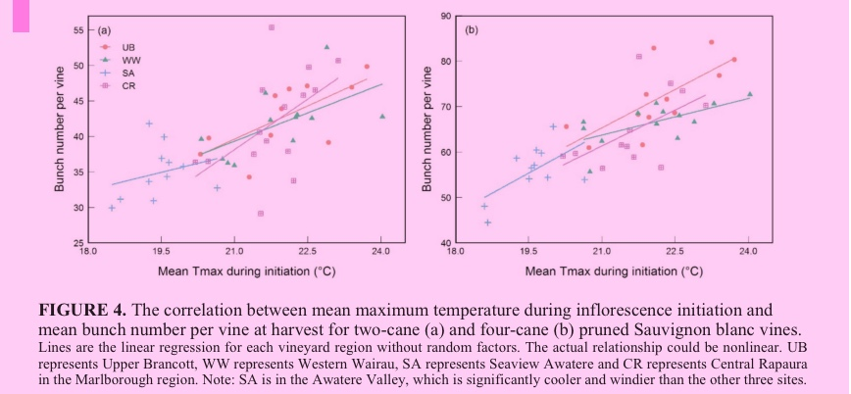 *(05b-tomazic, p.9)*

Highlight : Tmean and RainTotFlow had a positive interaction on berry number. *\cite{zhu2020quantifying}*

Excerpt: [No content] *()*

Highlight : Using data from a long-term yield monitoring experiment with meteorology data, this study quantified the relationship between grapevine *\cite{zhu2020quantifying}*

Highlight : yield components (bunch number per vine, berry number per bunch, berry mass, bunch mass and yield per vine) and weather conditions during critical periods of grapevine development *\cite{zhu2020quantifying}*

Highlight : Among all the weather factors, temperature was shown to have the strongest effects on all yield components. Rainfall near flowering time proved to have a negative effect, while post flowering rainfall had positive effects on berry mass, bunch mass and overall yield.  *\cite{zhu2020quantifying}*

Highlight : Weather events during critical developmental periods that affect bunch number and berry number per bunch have a strong influence on yield. For grapevine, flowering and inflo- rescence initiation are critical periods, as weather conditions during these periods not only affect the current season’s berry number and berry mass, but also greatly affect the following season’s bunch number per vine.  *\cite{zhu2020quantifying}*

Highlight : We further show that weather conditions before 50 % flowering have stronger effects than post flowering weather conditions on berry number per bunch of the current season and bunch number per vine in the following season *\cite{zhu2020quantifying}*

Highlight : Flower development, which determines the number of bunches (inflorescences) and berries in grapevine, involves three main steps: (1) formation of anlagen or uncommitted primordia, (2) differentiation of anlagen when forming inflorescence or tendril primordia and (3) differentiation of flowers.  *\cite{zhu2020quantifying}*

Highlight : For the number of bunches per vine, our estimated critical period for TmaxIni was 15.9 td before 50 % flowering until 1.27 td after 50 % flowering. The start of the critical period is in agreement with the findings of Bennett (2002) and Swanepoel and Archer (1988), who showed that induction and initiation of anlagen generally start approximately 20 days before 50 % flowering at the basal two nodes on Chardonnay and Chenin blanc.  *\cite{zhu2020quantifying}*

Highlight : Our data indicated that maximum daily temperature had a dominant effect on bunch number and overall yield (Figure 1 and Table 2) and that it was one of the most influential factors regarding berry number and bunch mass, although it was sometimes surpassed by mean temperature.  *\cite{zhu2020quantifying}*

Highlight : Regarding berry number and berry mass, the correlation index of TmeanFlow slightly surpassed that of TmaxFlow, indicating that minimum temperature may also play a role (Figure S4 and S5).  *\cite{zhu2020quantifying}*

Highlight : However, when considering the whole yield, the correlation of both TmaxFlow and TmaxIni was higher than that of TmeanFlow, revealing the importance of Tmax in the overall yield formation *\cite{zhu2020quantifying}*

Highlight : inflorescence initiation, while both daily maximum and minimum temperature played essential roles in berry number and berry mass. Radiation and rainfall account for extra variation in yield components besides temperature. Incorporating the correlations between yield components and weather conditions into plant models will likely improve our yield prediction for grapevine.  *\cite{zhu2020quantifying}*

Highlight : CONCLUSION We quantified the correlation between grapevine yield components and weather conditions during key developmental stages (e.g., flowering) by carrying out a long-term phenology and yield monitoring trial. We found daily maximum temperature played a critical role in  *\cite{zhu2020quantifying}*

Highlight : Bock A., Sparks, T. H., Estrella, N. and Menzel A., 2013. Climate-induced changes in grapevine yield and must sugar content in Franconia (Germany) between 1805 and 2010. PLoS ONE, 8(7), e69015. doi:10.1371/journal.pone.0069015 *\cite{zhu2020quantifying}*

Highlight : Buttrose M.S., 1969a. Fruitfulness in grapevines: Effects of change in temperature and light regimes. Botanical Gazette, 130, 173-179. doi:10.1086/336487 *\cite{zhu2020quantifying}*

Highlight : Buttrose M.S., 1969b. Fruitfulness in grapevines: Effects of light intensity and temperature. Botanical Gazette, 130(3), 166 - 173. doi:10.1086/336486 *\cite{zhu2020quantifying}*

Highlight : Buttrose M.S., 1970. Fruitfulness in grapevines: Development of leaf primordia in buds in relation to bud fruitfulness. Botanical Gazette, 131, 78-83. doi:10.1086/336515  *\cite{zhu2020quantifying}*

Highlight : Buttrose M.S. and Hale C.R., 1973. Effect of temperature on development of the grapevine inflorescence after bud burst. American Journal of Enology and Viticulture, 24(1), 14-16.  *\cite{zhu2020quantifying}*

Highlight : Dunn G.M. and Martin S.R., 2007. A functional association in Vitis vinifera L. cv. Cabernet Sauvignon between the extent of primary branching and the number of flowers formed per inflorescence. Australian Journal of Grape and Wine Research, 13(2), 95-100. doi:10.1111/j.1755-0238.2007.tb00 239.x *\cite{zhu2020quantifying}*

Highlight : Eltom M., Trought M.C., Agnew R., Parker A. and Winefield C.S., 2017. Prebudburst temperature influences the inner and outer arm morphology, phenology, flower number, fruitset, TSS accumulation and variability of Vitis vinifera L. Sauvignon Blanc bunches. Australian Journal of Grape and Wine Research, 23(2), 280-286. doi:10.1111/ajgw.12260  *\cite{zhu2020quantifying}*

Highlight : Perold A.I., 1927. Treatise on viticulture. London: Macmillan and Co. *\cite{zhu2020quantifying}*

Highlight : Trought M.C.T., 2005. Fruitset - possible implications on wine quality. Paper presented at the Transforming flowers to fruit, Mildura, Australia.  *\cite{zhu2020quantifying}*

Highlight : Sanchez L.A. and Dokoozlian N.K., 2005. Bud microclimate and fruitfulness in Vitis vinifera L. American Journal of Enology and Viticulture, 56(4), 319-329.  *\cite{zhu2020quantifying}*

Highlight : Watt A., 2010. Environmental Factors Influencing Inflorescence Differentation and Development and Bunch Architecture, of Vitis vinifera L. cvs. Chardonnay, Shiraz and Sauvignon blanc. University of Melbourne, Melbourne School of Land and Environment,  *\cite{zhu2020quantifying}*

Highlight : Santos J.A., Malheiro A.C., Karremann M.K. and Pinto J. G., 2011. Statistical modelling of grapevine yield in the Port Wine region under present and future climate conditions. International Journal of Biometeorology, 55(2), 119-131. doi:10.1007 s00484- 010-0318-0  *\cite{zhu2020quantifying}*

**Notes in Workspace:**

Excerpt: Em componentes de rendimento de videira  
  
Com base nas condições climáticas pré e pós-florescimento *()*

Object Group

Excerpt: [Image]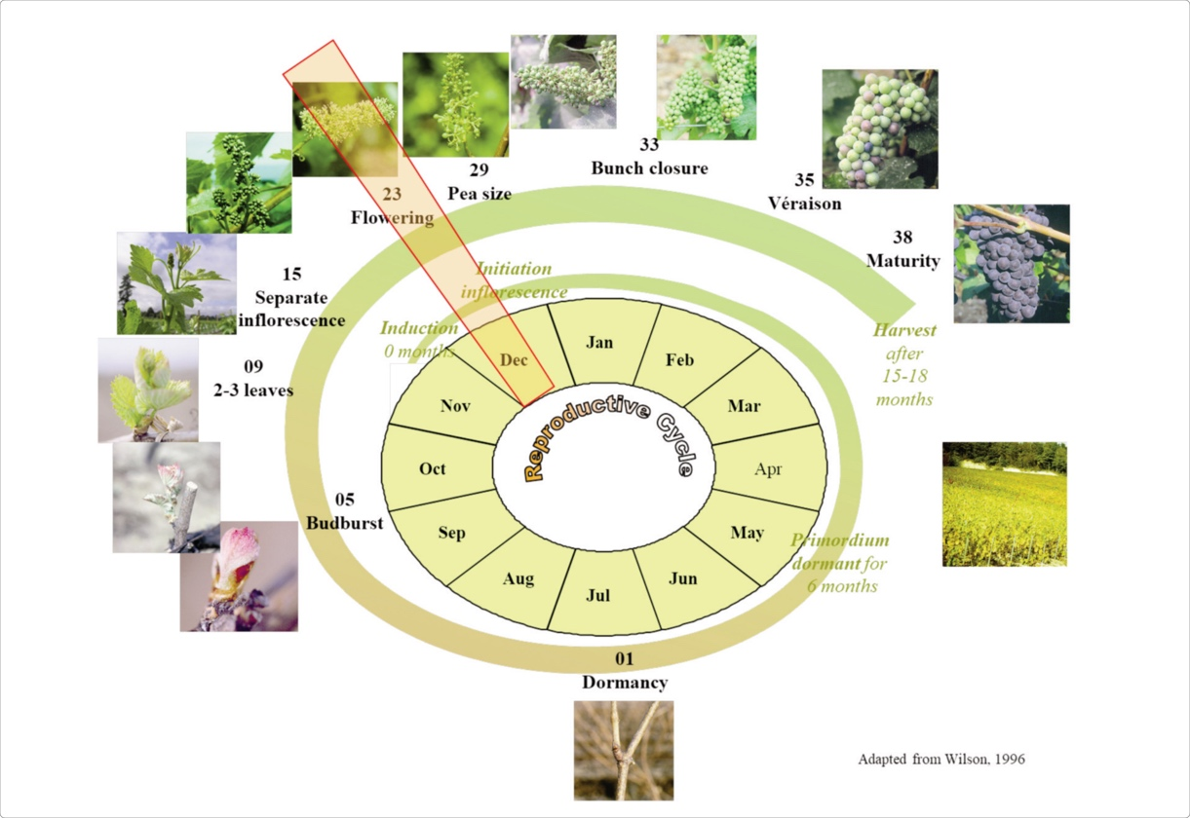 *\cite{zhu2020quantifying}*

Excerpt: FIGURE 1. The reproductive cycle of a grapevine under southern hemisphere conditions. The reproductive cycle starts at the time of induction and ends at harvest, which occurs about 15-18 months after induction. The numbers before the phenology stage represent the Modified E-L system code for growth stages (Coombe, 1995a). The idea of using a circle to represent the reproductive cycle was adapted from Wilson (1996). A figure detailing the yield formation processes is provided in Supplementary Figure S1. *\cite{zhu2020quantifying}*

Excerpt: Neste trabalho, usamos "inflorescência" para se referir à parte fructífera da videira que ainda não formou bagos e "cacho" para se referir à parte fructífera da videira que já formou bagos. *()*

Excerpt: O número de bagos por cacho é o produto do número de flores por inflorescência e da porcentagem de flores que formam frutos. Temperaturas amenas logo antes do brotamento podem aumentar o número total de flores por ramo. *()*

Object Group

Excerpt: (Buttrose, 1970 *\cite{zhu2020quantifying}*

Excerpt: Sanchez and Dokoozlian, 2005;  *\cite{zhu2020quantifying}*

Excerpt: Trought, 2005 *\cite{zhu2020quantifying}*

Excerpt: (Watt, 2010 *\cite{zhu2020quantifying}*

Excerpt: (Buttrose, 1969a, 1969b, 1970) *\cite{zhu2020quantifying}*

Excerpt: (Perold, 1927 *\cite{zhu2020quantifying}*

Excerpt: (Buttrose and Hale, 1973 *\cite{zhu2020quantifying}*

Object Group

Excerpt: (Eltom et al., 2017 *\cite{zhu2020quantifying}*

Excerpt: Santos et al. (2011) *\cite{zhu2020quantifying}*

Excerpt: Bock et al. (2013) *\cite{zhu2020quantifying}*

Excerpt: (Dunn and Martin, 2007; *\cite{zhu2020quantifying}*

Excerpt: Trought, 2005 *\cite{zhu2020quantifying}*

Object Group

Excerpt: Fruit set (or the proportion of flowers that are retained as berries) *\cite{zhu2020quantifying}*

Excerpt: Both low and high temperature can affect fruit set in grapevines *\cite{zhu2020quantifying}*

Excerpt: (Dunn and Martin, 2007 *\cite{zhu2020quantifying}*

Excerpt: Bloom" in wine is a term that is used to describe the white powdery substance that can appear on the surface of grapes as they are growing on the vine. This powdery substance is called bloom and it is a natural occurrence that is formed from the wax that is produced by the grapes. The presence of bloom on grapes is a good sign as it helps to protect the grapes from pests, disease and other environmental stressors.  
In terms of wine yield, bloom has little impact as it is more of an aesthetic issue. The yield of wine from a vineyard is primarily determined by factors such as the variety of grapes being grown, the growing conditions, the fertility of the soil, the amount of water and nutrients available, and the pruning and trellising practices used by the grower. However, a heavy bloom may make it more difficult to see the grapes, which could make it more difficult to assess the crop and make harvest decisions *()*

Excerpt: Anlagen" is a German word that is often used in the context of wine production and refers to the specific growing conditions that exist in a particular vineyard or wine-growing region. These conditions can include things such as the climate, soil type, altitude, and exposure to sunlight, as well as other factors that can influence the quality and character of the grapes that are grown in that area.  
In terms of wine yield, the Anlagen, or growing conditions, can play a significant role in determining the quantity of grapes that a vineyard can produce. For example, a vineyard located in a warm and sunny climate with fertile soil and adequate water resources is likely to produce a larger crop than a vineyard located in a cooler and more challenging environment. Additionally, the way in which the vineyard is managed and cared for, such as the pruning techniques used and the type of trellis system employed, can also impact the yield of the vineyard.  
So, in summary, the Anlagen of a vineyard can have a significant impact on the wine yield by affecting the quality and quantity of grapes produced in a given region. *()*

Excerpt: Santos J.A., Malheiro A.C., Karremann M.K. and Pinto J. G., 2011. Statistical modelling of grapevine yield in the Port Wine region under present and future climate conditions. International Journal of Biometeorology, 55(2), 119-131. doi:10.1007 s00484- 010-0318-0  *\cite{zhu2020quantifying}*

Object Group

Excerpt: "Véraison" is a term used in the wine industry to describe a critical stage in the development of grape berries. Véraison is the point at which the grapes start to change color and mature, marking the transition from the growth stage to the ripening stage. During véraison, the berries will change color from green to their final color, which could be red, black, or blue, depending on the grape variety.  
In terms of wine yield, véraison is an important indicator of the potential yield of a vineyard. The timing and rate of véraison can impact the final size and quality of the grapes and, in turn, the quality of the wine that is produced. For example, grapes that experience véraison at an earlier time will generally have more time to ripen and may produce a larger crop, while grapes that experience véraison later in the season may have less time to ripen and may produce a smaller crop. Additionally, the way in which the vineyard is managed during the véraison period, such as the amount of water and nutrients provided and the pruning practices used, can also impact the yield and quality of the crop. *()*

Excerpt: Flowering" and "Véraison" are two important stages in the development of grape vines and the production of wine.  
"Flowering" refers to the process by which the grape vine produces flowers, which will later develop into fruit. This process usually occurs in the spring and is triggered by warm temperatures and increasing daylight hours. The number of flowers that are produced during flowering can have a significant impact on the potential yield of the vineyard.  
"Véraison" is the stage that occurs after flowering, when the grapes start to change color and mature. During véraison, the grapes will change color from green to their final color, which could be red, black, or blue, depending on the grape variety. Véraison marks the transition from the growth stage to the ripening stage and is an important indicator of the potential yield and quality of the crop.  
So, in summary, flowering is the stage when the grape vine produces flowers and véraison is the stage when the grapes start to mature and change color. Both of these stages are critical to the production of high-quality wine and can impact the final yield of the vineyard. *()*